EN
European Economic and Social Committee

TEN/607
Mid-term evaluation of the Connecting Europe Facility
(formerly Smart Islands)

INFORMATION REPORT
Section for Transport, Energy, Infrastructure and the Information Society
Mid-term evaluation of the Connecting Europe Facility
(formerly Smart Islands)

Administrator | Cédric CABANNE
Document date | 08/03/2017
Rapporteur: Meelis JOOST

Consultation | European Commission, 22/06/2016
Legal basis | Rule 31 of the Rules of Procedure  Bureau decision of 20/09/2016
Section responsible | Transport, Energy, Infrastructure and the Information Society
Adopted in section | 10/02/2017

Conclusions

The EESC welcomes the opportunity to take part in the evaluation of the Connecting Europe Facility (CEF), which aims to improve infrastructure in the fields of transport, energy, and information and communication technologies (ICT). The response is based on the EESC's various discussions held on the topic, as well as its Smart Islands project, which analyses primary data collected through fact-finding missions which took place in 2015 and 2016.

The fact-finding missions demonstrated the need of islands for smaller-scale projects that connect them to the mainland and to each other. These projects are not only essential for transport but also for ICT and energy.

The EESC calls on the Commission to pay special attention to the efforts made by EU islands, particularly those that have been adopting smart solutions. Many projects in the planning or implementation phase require technical assistance and funding.

Broadband connections and free WIFI are crucial for European island communities. Affordable broadband connections would allow for increased use of smart tools for teleworking, e-commerce and education, enabling islanders to continue living on their islands.

Renewable energies, such as wind, geothermal and tidal energy, and energy efficiency systems, such as smart grids, heating and street lighting, should be accessible to islanders and promoted through the dissemination of a catalogue of smart islands projects and a list of available funding schemes.

Innovative, accessible and affordable modes of maritime and inland transport are crucial for the development of sustainable tourism. Local policies such as soft mobility should be widely disseminated among island communities.

The EESC recommends that local authorities use an interactive approach involving residents and civil society when designing and implementing smart projects. Multilevel governance tools such as SmileGov, which is used by many European islands, should be highlighted as a suitable model.

General comments

EU islands face identical challenges, such as territorial discontinuity, demographic desertification, strong seasonal fluctuation in the number of residents and visitors, energy dependency on fossil fuels, waste management, water supply and funding scarcity. Islands are responding to these challenges by developing innovative and small-scale projects in the fields of ICT, the environment, energy, transport, tourism development and commerce, as well as governance.

European island communities require funding in all three CEF thematic areas, since many smart solutions in the fields of energy, transport and ICT are emerging that are not funded by the CEF. Substantial funding is particularly required for sustainable energy development, present in all of the island communities visited as part of the EESC Smart Islands initiative.

Effectiveness

The UNFCCC Paris Agreement is paving the way to a transition towards a low carbon economy. Smart islands have already started this journey, creating synergies between ICT, the environment, energy, transport, tourism and commerce.

EU island communities are seeking cooperation with each other, introducing tried and tested smart solutions from other island communities to communities where they have not yet been implemented. The synergies developed by transferring these solutions can contribute to sustainable development, for example the sustainable energy policy of Samsø, Denmark could be tried out on the island of Favignana, Italy.

Efficiency

The introduction of renewable energy sources into the power mix on the island of Kythnos is a good example of energy being supplied through a decentralised production process. In a remote area of the island, where it is not possible to connect to the grid, a photovoltaic module produces electricity which is then fed into the local microgrid.

The island of Samsø's broadband community offers a smart solution in the area of ICT. Having understood how expensive it would be to access country-wide providers, the islanders set up their own broadband supply, taking control of the services and technical back-up.

Efficient and ecological transportation has been introduced to the Île d'Yeu, where visitors are encouraged to leave their cars on the mainland in order to preserve the island's nature and heritage. Instead, visitors can rent bicycles in order to travel around the island.

Relevance

The CEF plays an important role in bringing Europe closer together. Investments in European island communities help to remove the obstacles that arise when implementing the basic EU freedoms, particularly the free movement of people and goods.

However, there is a need for smaller-scale and innovative projects for European islands. Example of these include high-speed broadband networks, free wifi in public spaces (for example, the new EU WIFI4EU initiative) and in outdoor spaces (based on the WIFI Palma model), access to renewable energy and smart grid systems, and soft mobility through the development of maritime and inland transport modes that use alternative fuels such as biogas derived from waste.

The Pact of Islands is an attempt to bring island communities closer together. Joint policies and projects would find it easier to achieve funding from EU instruments such as the CEF, the European Fund for Strategic Investments (EFSI) and the EU Structural Funds.

Coherence

More investment in smart energy, transport and ICT solutions is needed. The projects implemented and the solutions adopted help to preserve environments that might otherwise be threatened. The investments studied in connection with the Smart Islands project provided alternative incomes and alternative ways of living, which in turn increased the opportunities for remaining on an island.

In cases where funding solutions for smart projects have been developed, the implementation is coherent and sound. However, projects often do not find the necessary funding, either due to lack of information or poor capacity.

EU added value

The free movement of people, goods and services is a core principle of the EU. The Connecting Europe Facility is making it possible to put that principle into practice. After the enlargements of 2004, 2007 and most recently 2013, the connectivity challenges have increased. Many island regions of the EU are not sufficiently interconnected, an issue which requires the close attention of the EU and the Member States.

The Connecting Europe Facility can provide added value for Europe, not only in terms of funding for projects aimed at the more remote areas such as islands, whose geographical distance and separation from the mainland cause them problems, but also in terms of supporting the European project, as the visits have served to make the local population aware of how much the European Union can do in practical terms to bring these areas and their inhabitants closer to Europe.

Brussels, 10 February 2017

Pierre Jean COULON
The president of the Section for Transport, Energy, Infrastructure and the Information Society

*

* *

N.B.: Appendix overleaf – comprehensive overview TEN Section Report on the Smart Islands Project (EESC-2016-04387-00-05-BRO-TRA)
- Also available in electronic version in EN and FR

_____________
APPENDIX TO THE INFORMATION REPORT

Mid-term evaluation of the Connecting Europe Facility

of the Section for Transport, Energy, Infrastructure and the Information Society

TEN Section
Report
on the Smart Islands Project
EN

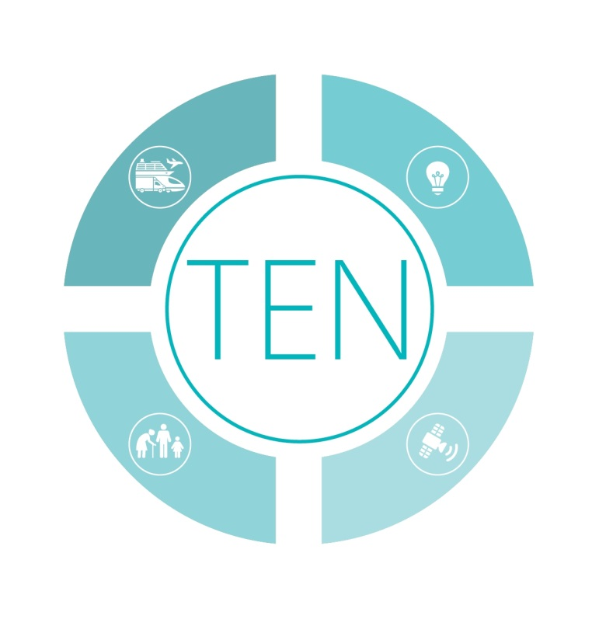

European Economic and Social Committee

Project members

Stéphane Buffetaut, member
Pierre Jean Coulon, TEN Section president
Meelis Joost, member and project leader
Charles Vella, member

Table of Contents

Presentation of the islands
1. Introduction 12
1.1 Methodology of the EESC project 12
1.2 Geographical information on the islands 12
1.3 Challenges 12
2. Information and Communication Technologies (ICT) 14
2.1 Best practice demonstrated during on-site visits 14
2.2 Big data and tourism 14
2.3 Emergency Quick Response Code 14
2.4 Internet broadband community 15
2.5 Virtual care and services for the elderly population 15
2.6 Smart small harbour services 16
3. Innovation, including energy, transport and environment 17
3.1 Best practice demonstrated during on-site visits 17
3.2 Offshore wind farm 17
3.3 Solar energy 18
3.4 Energy efficiency and sustainable mobility 18
3.5 Straw-fuelled heating systems 19
3.6 Introduction of renewable sources of energy in the power mix 19
3.7 Public filtered water fountains to prevent plastic waste 21
3.8 Marine Protected Area (MPA) 21
4. Tourism development 23
4.1 Best practice demonstrated during on-site visits 23
4.2 Redevelopment of the old processing factory 23
4.3 Hiking and exploration trails 23
4.4 Recreational fishing 24
4.5 Ecotourism, preserving the heritage of renewable energy 24
4.6 Preservation of the local architecture 24
4.7 Cultural and heritage centre 25
4.8 Geoparks 25
5. Economic development other than energy or tourism 26
5.1 Best practice demonstrated during on-site visits 26
5.2 Shipyards 26
5.3 Small-craft competence centre 26
5.4 E-commerce 27
5.5 Turning a declining market into a landing point 27
5.6 Short supply chain 27
5.7 Circular economy 28
5.8 Labelling the island's products 28
6. Scientific initiatives to protect the marine environment 29
6.1 Best practice demonstrated during on-site visits 29
6.2 Coastal observing and forecasting system 29
6.3 Protection and study of marine meadows 30
6.4 Rescue centre for Sea Turtles and Monk Seal Observatory 30
7. Smart solutions in governance and social innovation 32
7.1 Best practice demonstrated during on-site visits 32
7.2 Methods of cooperation 32
7.3 SmileGov project 32
7.4 The Pact of Islands 33
7.5 Redeveloping the urban environment 33
8. Recommendations 34
8.1 Introductory remarks 34
8.2 EESC recommendations 34
8.2.1 General recommendations 34
8.2.2 Information and communication technologies (ICT) 34
8.2.3 Energy and transport and the environment 35
8.2.4 Tourism development 35
8.2.5 Economic development 35
8.2.6 Scientific initiatives 36
8.2.7 Governance 36
9. Conclusions 37

Presentation of the islands

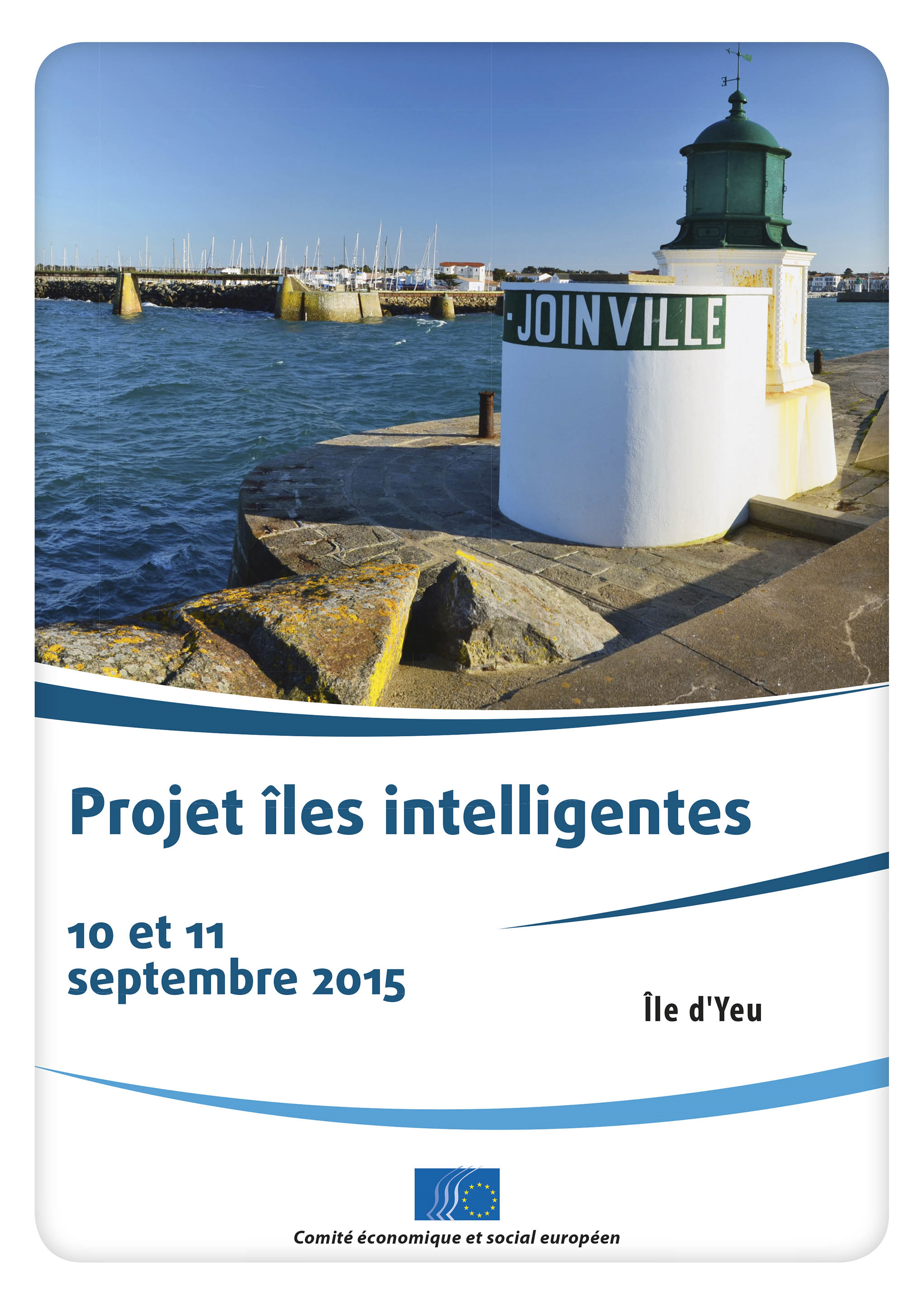 | Located in the Atlantic, Île d'Yeu is an island and a municipality, just off the Vendée coast of western France. With a surface area of 23km², the island has 4 600 inhabitants. Around 10km long with an average width of 4km, its surface area is around 23km². The island's two harbours, Port-Joinville in the north and Port de la Meule, located in this rocky inlet of the southern granite coast, have been famous for the fishing of tuna and lobster. However, the decline of fishing activities is pushing Ile d'Yeu's community toward the development of tourism, renewable energy and the digital economy.
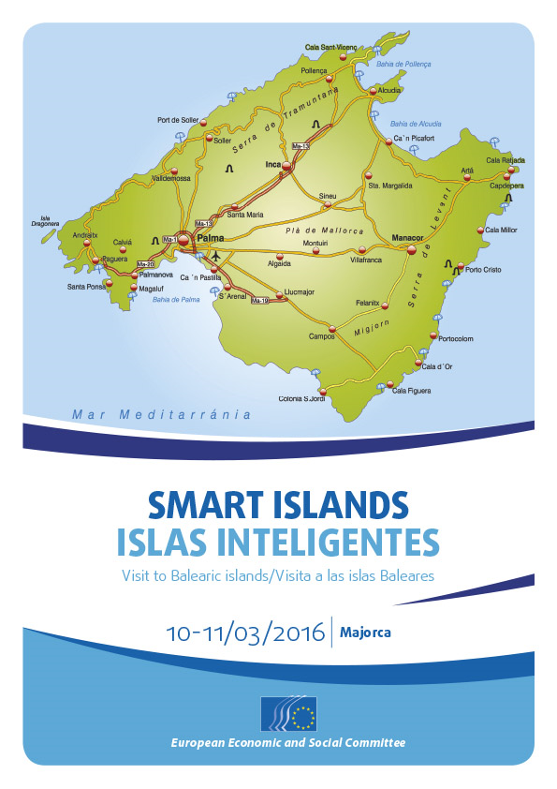 | The Balearic Islands are located in the middle of the Mediterranean Sea, and have a population of 1.120 million. Majorca is the largest island in the archipelago which has a total surface area of 4492km². The island's capital, Palma, is also the capital of the autonomous community of the Balearic Islands.  Since the 1970s, the archipelago's economy has diversified from a model based on subsistence farming to one based on tourism. However, the Balearic Islands are facing saturation of the traditional tourism model. The answer is to diversify tourism by exploiting digital and new technologies. The objective is to make the islands more competitive by boosting the economy using innovation, particularly in the digital economy.
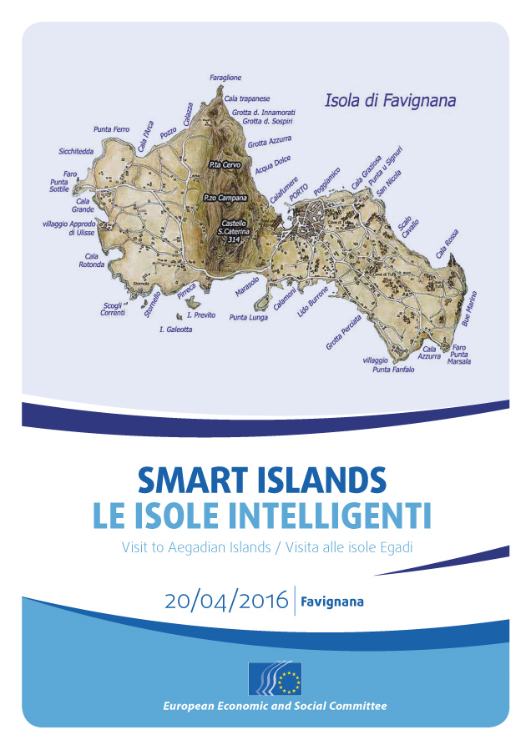 | Located in western Sicily, the Egadi Islands are an archipelago of 37.45km² made up of three main islands (Favignana, Levanzo and Marettimo) and two islets (Formica and Maraone). The main municipality, Favignana, includes the three islands of Favignana, Marettimo and Levanzo. Favignana is the largest of the three main Egadi Islands, with a surface area of 19.8km² and a population of 4 230 (31 December 2015). The island is famous for its caves of calcarenite rock (locally known as "tufo") and the ancient fishing technique of "tonnara", which involved the trapping and "mattanza" (culling) of Bluefin tuna.  Essentially based on tourism and fishing, the economy is driven by the Egadi Marine Protected Area (MPA), established by the government and managed since 2001 by the Municipality of Favignana. It is the largest marine reserve in the Mediterranean and has shaped a local policy which aims to extend the tourist season, repopulate the island and boost the economy.
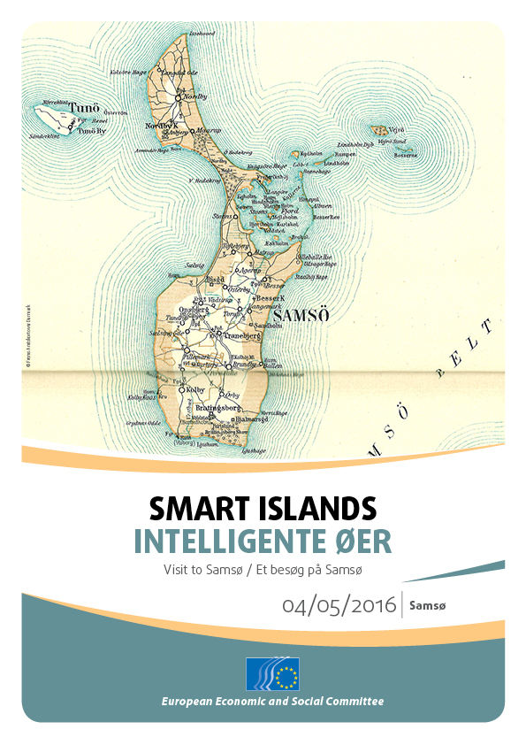 | Samsø is a Danish island and municipality located 15km off the Jutland Peninsula. Covering an area of 114km², the island was used during the Viking Age. Part of the island is Natura 2000 protected. The population of Samsø fluctuates from 3 700 (winter) to 25 000 (summer). The island is split between the north and the south. Residents use around 1 500 vehicles and have a network of cycle paths. Samsø's economy is based on small-scale fishing, farming (particularly potatoes and asparagus) and tourism. Ten years after the Kyoto Protocol entered into force (1997), Samsø won a national competition, reaching 99.6% renewable energy within ten years. Samsø is meeting its challenges (demography, transport and waste management) through an interactive approach which is already operating very well in the field of energy.
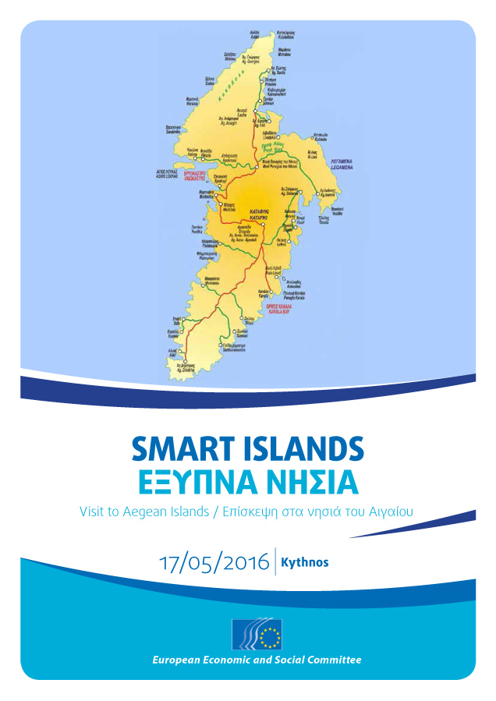 | Kythnos is a 100km² island and municipality located in the Western Cyclades. Very windy, the island hosts the first wind farm ever installed in Europe. The north of the island is a Natura 2000 protected area.  Kythnos's economy was driven in the 19th century by mining activities (e.g. iron). Today its economy is based on small-scale fishing, the diversification of agriculture toward products with Geographical Indications (GIs), and the development of a sustainable tourism model.  The island's population is around 2 400, rising to 25 000 during the summer. Remarkably, the local population is increasing. Today, the population is "ready to promote Kythnos", adopting soft development (as opposed to the excessive tourism activities which prevail in Mykonos, for instance). Kythnos is also on the way to developing a Sustainable Energy Action Plan Master Plan Proposal entitled "Smart Island Kythnos".
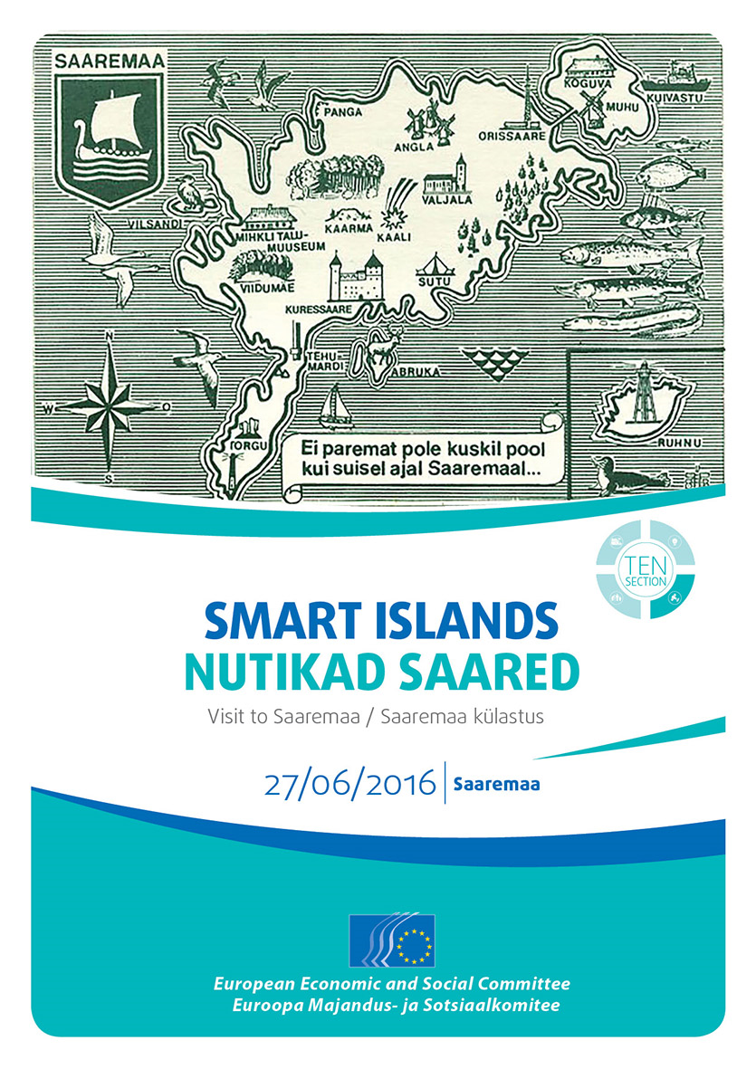 | Located between the Gulf of Riga and the Baltic Sea, Saaremaa is the largest of the 2 222 Estonian islands. Measuring 2 673km², this big island has a population of 33 000, which is shrinking. The island's economy is diverse and generates growth and jobs, as illustrated by the industry. Apart from food, shipyards, small craft building, electrical equipment, plastic products (films for garbage and seals for car air conditioning systems), the municipality estimates that 94 SMEs employ around 1 000 people. In addition, companies from abroad are developing activities.  Relatively wealthy, Saaremaa is trying to increase tourism and to improve its accessibility.
Smart Islands project

Introduction

Methodology of the EESC project

The Smart Islands project is based on the EESC TEN section's own-initiative opinion TEN/558 on Smart Islands, which was adopted on 19 March 2015. The project aims to gather feedback from island communities and to identify best practices introduced on some of the islands, which could suggest similar or adapted solutions for other island communities in the EU. In practical terms, the EESC is identifying remarkable infrastructures and network initiatives developed and often implemented in an interactive way.

The methodology is based on:

- the identification of islands, based on the current definition: territories with a minimum of 1km², a minimum distance between the island and the mainland of 1km, a resident population of more than 50 inhabitants, and no fixed link (such as a bridge, tunnel or dyke) between the island and the mainland;
- the location in Europe's oceans and seas: Aegean Sea, Atlantic Ocean, Baltic Sea, Mediterranean Sea, North Sea;
- six fact-finding missions;
- a questionnaire (set out in the Annex) sent to local players.

Geographical information on the islands

The project focused on Île d'Yeu in France, Mallorca in Spain, Favignana in Italy, Samsø in Denmark, Kythnos in Greece and Saaremaa in Estonia.

These islands represent a sample of islands in the EU. They range in surface area between 23.32km² for Île d'Yeu and 2 714km² for Saaremaa, 38.32km² for Favignana, 99km² for Kythnos, 114.26km² for Samsø, and 208km² for Mallorca. Geographically, the islands are spread across the Aegean, Mediterranean, North and Baltic Seas and the Atlantic Ocean.

Challenges

Despite their differences, all these islands face the same challenges: overcoming the difficulties associated with geographical separation and distance from the mainland; solving the conundrum of public facilities that need to be able to meet peak demand during the tourist season but may be excessive for most of the year (information and communication technologies, energy, transport, waste collection and processing, sewage treatment, etc.); maintaining the demography; organising the necessary educational structures and providing vocational training and jobs for local people; guaranteeing the livelihoods of people working in the tourist industry, who have short seasons and often perform several different jobs; protecting the natural coastal and marine environment that is put under significant pressure at certain times of year; finding the necessary funding to provide public services when the year-round population is often small and ageing; and providing affordable housing for young people when holiday homes, the protection of natural areas and limitations on areas approved for building development all lead to high housing costs.

The size and population of Mallorca mean that it is very different from the other islands visited, with their small size and low population. In general, islands constitute a concentrated version of the economic, social and environmental difficulties encountered on the mainland, albeit exacerbated by their limited size.

The solutions proposed vary, but they all satisfy the desire to make the most of technological and environmental limitations, and they all require flexibility, adaptation, inventiveness and hard work.

Information and Communication Technologies (ICT)

Best practice demonstrated during on-site visits

The EESC noted the development of big data in the field of tourism and the emergency QR project in Mallorca, the Internet community on Samsø, virtual care and services for the elderly on Saaremaa, and the Marina Ahoy smart solution for small harbours in Estonia.

Big data and tourism

The municipality of Palma de Mallorca is currently the second largest "wifi" city, after Miami (USA).Wi-Fi Palma is a project run by Universitat de les Illes Balears on big data and tourism. The project is being developed in cooperation with the Supercomputing Centre in Barcelona, the most powerful supercomputer in Spain. In order to increase its attractiveness as a tourism centre, the Majorcan authorities have provided free wifi access across the entire island since 2014. In some areas work is still under way, but in Palma de Mallorca, especially in the city centre, and on Playa de Palma, people have free wifi access. The hotspots were technically improved so everyone could move around the city without losing connection. Providing wifi on the beach promenade of Playa de Palma is intended to identify new trends (shopping, cultural and sport activities), which will help Palma to propose tailored activities for tourists. The project also has considerable potential for user groups who need special attention (i.e. people with mobility impairments), as users' behaviour can be monitored. Potentially, it may be possible to see whether fully accessible venues (i.e. for people with disabilities, elderly people using mobility devices, families with baby strollers) are more likely to be visited than venues which are not accessible to these target groups.

The project processes data confidentially. Data protection is a key topic in such projects and needs to be addressed considering that, if handled carelessly, online storage of data can have serious and undesired implications.

Website for the smart project developed by Palma: http://smartoffice.palma.cat

Emergency Quick Response Code

The Balearic Islands have a long tradition of tourism, which is reflected in its wide range of tourist facilities and services. In August alone at the peak of the tourist season, Mallorca usually has over 13 million tourists. The emergency and police authorities are involved daily in 150 to 200 interventions, of which 50 to 80 can be resolved swiftly. The main problems are lost children, people who have lost their bearings and injured cyclists.

In order to promote the Balearic Islands as a destination, the Balearic authorities, including the port authorities, are giving due consideration to the issue of security, combining public, medical and environmental safety.

To improve the security and safety of tourists, the port authorities and the authorities of the Balearic Islands asked the University of Palma to develop an emergency system. A QR code (abbreviation for Quick Response Code) system is being developed for this purpose. The QR code is a machine-readable optical label that contains information about the item to which it is attached. It consists of black modules (square dots) arranged in a square grid on a white background, which can be read by an imaging device (such as a camera or scanner).

In practice, the system has been used from summer 2016 for cruise tourists disembarking for a short period in Palma. The MSC Company will include the QR code in the medical questionnaire shared with the Spanish emergency system (112, hospitals, doctors). The QR emergency system is particularly suitable for groups with special needs (people with disabilities, minors and senior citizens, sportsmen, etc.). 2 045 characters can be stored on the square code. The system is totally safe since the information (identity, medical information, contacts and GPS location) is not stored online but encrypted and printed in the square. The information is only readable using the requisite application and can always be updated by the person providing data about him/herself.

Using the QR code is also better than calling an ambulance or the police in all cases, as that will cause a serious disturbance in a tourist area. One challenge is to convince visitors to start using the QR codes on themselves, as this cannot be made compulsory. The project has great potential for island destinations which receive many seasonal visitors, often by cruise ships, who stay for a short time and would not become sufficiently familiar with the destination to be able to help themselves easily in an emergency.

Website de Ports de Balears: http://www.portsdebalears.com/es

Internet broadband community

In 2012 the inhabitants of Samsø started to provide high-speed internet themselves, having experienced bad connections with earlier providers and a final provider who went bankrupt. The initiative has been run by the inhabitants themselves, initially on a voluntary basis. This initiative provides a better and cheaper connection than most of the private broadband companies operating in the country. Only in April 2015 was the first paid technician hired. By April 2016, the network had 1 199 users, for an island of 3 700 year-round inhabitants. The project is supported by the Danish government.

Website for the initiative: http://net4samso.dk

Virtual care and services for the elderly population

On Saaremaa, the VIRTU/ELVI project aims to connect elderly people via the internet. The project started a few years ago as an EU Interreg project and is currently financed and sponsored by one of the nation-wide telecom enterprises (TELIA). The remote care service aims to improve the activity of elderly people and to save public money. The project also helps to maintain links and relations between elderly people and their relatives by increasing internet communication.

On the island, 20 people are connected to the initiative. The system helps people to socialise throughout the year, while the most frequent use is during the winter, when moving around is a bigger challenge for elderly people who often also have impaired mobility. People use VIRTU to avoid being isolated. The system requires a computer, a screen and internet. It can be used for bilateral meetings, group activities (e.g. singing) and to organise 24-hour surveillance. The service keeps people active, when they live in very remote areas or are unable to attend gatherings frequently. Online events are organised for the target group and the feedback has been positive. Users can communicate with each other as well as meet people or get back in touch. The initiative has great potential for sparsely populated areas with limited accessibility, which often include island communities.

Website for the initiative: http://virtuproject.fi

Smart small harbour services

On Estonian islands and coastal harbours, it is difficult and costly to manage small harbours and provide services, as the numbers of visitors and residents is limited. In response, the authorities are encouraging, improving and expanding the network of harbours. A smart harbour system is being developed as part of solutions involving 50 harbours across Estonia. Information is provided for tourists, including online booking (accommodation and transport). An automated management system has been set up, including mobile payments. This "marine mastermind" model and the concept of "easy port" are particularly suitable for low tonnage vessels, small ports and service suppliers. Saaremaa is also changing its "business model" by receiving more cruise ships. A business label is emerging from the initiative.

The same model could be used for bigger boats and bigger harbours, and is not limited to one country; it can be enlarged and rolled out by other island and coastal communities. It could be a good solution for sparsely populated communities, where manning small harbours is not possible simply because the manpower would not be available.

Website for the initiative: www.marinaahoy.com

Innovation, including energy, transport and environment

Best practice demonstrated during on-site visits

The EESC observed several initiatives, such as the offshore wind farm and reduction of traffic on Île d’Yeu, solar energy on Favignana, energy efficiency and sustainable mobility on Favignana, use of straw from local farms for collective heating systems on Samsø, the introduction of renewable sources of energy in the power mix on Kythnos, the Energy Academy of Samsø, public filtered water fountains to prevent plastic waste on Favignana, and the Marine Protected Area of the Egadi islands.

Offshore wind farm

Together with Île de Noirmoutier, Île d’Yeu is planning to build an offshore wind farm. The farm would be built for 25 years of use. Île d’Yeu would be used as a base for construction and the project would create jobs for the islanders, partly since Île d’Yeu would be required to set up a maintenance base for the wind farm (setting up a maintenance base on the island means providing training for islanders and bringing in new skills and therefore new inhabitants/families to the island).

The wind farm would have 62 turbines and be located 12km out. It would have an output of 496MW, a surface area of 82.5km² and an estimated cost of EUR 2 billion.

The project promoters have been confronted with protests against the farm because of the visual impact from the seashore. There are also concerns about fishing, but scientific experts generally consider that such construction has a positive impact on the renewal of fish stocks. These examples clearly show that dialogue with civil society is vital throughout such projects. People need dialogue and information.

This initiative is necessary for the development of the island, and is backed by Île d’Yeu's excellence in energy, with its successful Yeu 2030 energy transition programme. The goal is to make Île d’Yeu a showcase of excellence in energy with local and renewable energy generation, energy storage (development of hydrogen storage), a smart grid project, etc. Another aspect involves reducing energy consumption by promoting energy-efficient building renovation and energy savings. From an economic point of view, the aim is to develop new markets, make companies more competitive and increase skill levels. Technological innovations in the field of energy transition also need to be accommodated (islands are an ideal test-bed given that input and output flows can be measured accurately).

From a social point of view, considerations involve combating energy poverty and reducing inequality in the face of rising energy costs. This ambitious action programme has received wide acclaim. Île d’Yeu is among 212 French districts lauded for their contribution to green growth ("Territoires à énergie positive pour la croissance verte").

Website for the project: www.iles-yeu-noirmoutier.eoliennes-mer.fr

Solar energy

On Favignana, energy generation is a challenge. The Egadi Islands are not connected to each other, nor are they connected to the Sicilian mainland. The cost of energy generation is high for the population. Another problem is related to the level of consumption, which differs in summer and winter (households do not use heating systems in the winter, while consumption rockets during the summer due to the use of air conditioning and tourism). The municipality's storage capacity is only 30KW. For the time being, wind energy is not allowed due to a law protecting the landscape. It is impossible to develop a gas plant, unless the municipality builds a methanation unit. One private project to develop a new power plant is in breach of the MPA. Solar power is used as described in the Sun and Stars of the Egadi Islands project.

Website for the project:
http://www.comune.favignana.tp.gov.it/po/mostra_news.php?id=174&area=H

Ten years after the Kyoto Protocol entered into force (1997), Samsø won a national competition, reaching 99.6% renewable energy within ten years. On this Danish island, wind energy predominates thanks to a combination of offshore and land-based windmills, but there is solar energy as well. The EESC visited a farm, whose owner has begun the transition from traditional farming to energy generation. The farmer has invested in solar panels which are installed on the stables and barn. In addition, to achieve scale, the farmer has invested in solar panels installed on factories in Germany and Italy, generating energy which is sold and injected into the grids. Shifting from traditional farming remains a challenge in all of Europe's developed countries, which is why the farm has diversified while also contributing to increased use of renewables.

Energy efficiency and sustainable mobility

On Favignana, the "Sun and the Stars of the Egadi islands" project began in 2008, following a call for funding from the Italian Ministry of the Environment. The project has a number of pillars:

- Soft mobility: through the purchase of electric and hybrid vehicles for the city administration, and incentives for local residents and economic operators. In practical terms, financial contributions are granted to encourage the use of mountain bikes, electric bicycles and electric scooters. The initiative is open only to residents and local economic operators (e.g. accommodation and vehicle hire).
- Renewable energy: the public sector has already installed 6.72KW solar panels on the roof of the town hall, and 10.2KW panels on the school roof. Solar thermal energy installations are authorised only if they protect the landscape – the solar panels should not be visible and so spoil the island's heritage. Households applying for funding will be reimbursed for 30% of the cost of the installation.
- Energy efficiency: public lighting bulbs are being replaced by LEDs. Economic operators are given incentives for any investments in electrical bicycles and heat pumps.
- Recycling of vegetable oil: although the oil can be collected and recycled, residents have not yet started doing so.

The project is largely aiming to change mindsets, as traditionally the islanders have had little to do with using renewable energy. This initiative is a good start for further projects in renewable energy and innovation.

In France, tourists going to Île d'Yeu are encouraged to travel by train, bus and ferry.

Access to Île d'Yeu is mainly provided by ferries of the Régie Départementale des Passages d’Eau de Vendée. Soft mobility is encouraged through a system of tariffs aiming to reduce use of personal vehicles (e.g. cars, motorbikes, bicycles).

Website for the maritime transport company: http://www.yeu-continent.fr/

Straw-fuelled heating systems

In Denmark, energy generation is turning to renewables, even though the country has two coal-fired power plants. For the time being, most energy is supplied by biomass and waste.

Samsø has four public cooperative district systems, three of which are straw-fuelled heating stations and one a station combining woodchip and solar power. One straw-fuelled heating station is a 10-year project with a unit working at local level. The working principle is that 3kg of straw produces the equivalent of 1 litre of oil. Households themselves own the plant and the remote heating water loop. The system produces very cheap energy. The straw used comes from Samsø's fields, although 20% of the straw is left on the land to regenerate and protect the soil. To be optimised, the straw needs 50% humidity. The straw is stored in the plant and then burnt. The energy heats a 6km water loop which is connected to households. Ash is stored and spread on the fields as a fertilizer.

The initiative is part of Samsø's fossil-free island philosophy. The broad energy mix, including the remote heating option combined with earth-heating, solar panels and wind energy is widely spread and so helps more and more inhabitants mobilise sustainable solutions for energy consumption.

Introduction of renewable sources of energy in the power mix

Kythnos's challenging geography encourages the use of local and renewable sources of energy. Several generation solutions are present on the island. The introduction of renewable energy sources into the power mix of Kythnos grid is key, particularly for an autonomous island supplied mainly by diesel generators. Although the wind and solar potential in these areas is excellent, the strong seasonal fluctuations in demand as well as the technical restrictions were a problem.

The Aegean Energy and Environment Agency together with the Municipality of Kythnos are currently promoting the island of Kythnos as a "test-bed" for innovative technologies. This effort builds on a rich history of cutting-edge technology deployment on the island, namely:

  - 1982: Installation of the 1st wind park in Europe (5 x 20kW);
  - 1983: Installation of a 100kW photovoltaic (PV) system with battery storage (400kWh);
  - 1989: Replacement of the wind turbines (5 x 33kW);
  - 1992: Inverter installation for the PV system;
  - 1998: Installation of a 500kW Vestas wind turbine;
  - 2000: Installation of a fully automatic control system (Intelligent Power System);
  - 2001: Operation of a PV-powered autonomous microgrid with batteries and diesel generator back-up in the Gaidouromandra area.

A hybrid power plant system with battery storage and an intelligent management system on Kythnos combines diesel generators, wind turbines and solar panels, with a battery storage unit and a converter to alternating current. In practical terms, the power plant system can produce up to 2.8 megawatts during the summer. Although the most recent wind turbines are not connected, the system meets the island's demand. When solar energy covers demand, the diesel system is automatically turned off, and vice versa. The electricity is transported, stored and converted. During the winter, the system provides renewable energy for 12 or 13 hours per day. The diesel unit is made up of four diesel generators of 300kW and three of 400kW. A diesel engine is used as a back-up.

Three times a year, a ship delivers oil to the harbour. 16 truck convoys are needed to carry the oil. Energy and a converter are funded by the EU.

The microgrid of Gaidouromandra is a stand-alone system which is not connected to the island's electrical system. PV modules produce electricity which is fed into the local microgrid, powering a number of summer houses and one farm. The excess electricity is stored in batteries while a diesel generator is available as back-up. Inverters and power electronics ("Sunny Boy" and "Sunny Island") which were installed for demonstration purposes maintain the efficient operation of the microgrid. The microgrid is monitored and maintained by CRES, the Greek national entity for the promotion of renewable energy sources, rational energy use and energy conservation.

Furthermore, smart meters are currently being installed in Kythnos, in the context of the "Smart Grids in five Aegean Islands – Development of smart-grid infrastructure in autonomous islands of the Aegean Sea" project, run by the European Local ENergy Assistance (ELENA) programme of the European Investment Bank (EIB). The programme is funded through the European Commission's Horizon 2020 programme. Overall, the project will promote smart grids in the five Aegean islands, including Kythnos, in order to improve the quality of electricity provision, foster the penetration of renewable energy in local energy production and make energy loads more flexible through consumption-based measures.

Building on the above, Kythnos, as one of the five demo sites across Europe for the HORIZON2020 project WiseGRID project, will host a state-of-the-art integrated electricity system that includes:

- electrical vehicle charging stations;
- procurement of electrical vehicles;
- energy storage systems (batteries) for public/municipal buildings;
- equipment for optimising the operation of a desalination plant;
- energy storage systems (batteries) to increase renewable energy penetration in the local energy mix;
- equipment for the flexible and optimal operation of the electricity network.

Website for WiseGrid project: http://www.wisegrid.eu/
Website for ELENA programme: http://www.eib.org/products/advising/elena/index.htm

Energy Academy

Samsø has amassed a great deal of experience with a wide variety of local renewable energy projects, from wind turbines to CO₂-neutral district heating plants, rapeseed oil tractors and solar energy panels. Logically, the Samsø Energy Academy, situated close to the picturesque harbour village and tourist magnet Ballen, developed as a competence centre to spread information about smart solutions in energy.

This experience can be drawn upon through the Academy, and local and foreign researchers and scientists spend time at the Academy performing research based on the easy access to all these energy systems, where windmills, straw-fuelled district heating and thermal solar panel systems and the people who initiated them are close at hand.

The Academy also functions as a conference centre where companies, scientists and politicians can discuss renewable energy, energy savings and new technologies.

Samsø Energy and Environment Office, Samsø Energy Agency and the Samsø branch office of the Danish Energy Service are located in the Energy Academy. From here, they run a broad spectrum of energy counselling services for commercial and private customers, organise guided energy tours, workshops and seminars and generally promote ‘energy tourism’ for energy professionals.

Being very active in Europe in the area of energy mix, the Energy Academy is also opening its doors to visitors from third countries such as Japan.

Website for the initiative: www.energiakademiet.dk
Website for the project: www.visitsamsoe.dk/en/inspiration/energy-academy/

Public filtered water fountains to prevent plastic waste

On Favignana, a micro-filtered water project began in 2014. 300 000 litres of water have been distributed to the island's population through one outdoor fountain. The main objective of the fountain is to reduce plastic waste. Since 2014, it is estimated that the equivalent of 150 000 plastic bottles have been saved. The project also has a social impact since the water (natural or sparkling) is free for local households, which are entitled to up to ten litres per day. Once extracted, the ground water is micro-filtered. For the time being, the fountain consumes energy supplied locally by a diesel-operated power plant. However, solar panels will soon be installed on the fountain. The island of Favignana will need additional units to cover local needs.

Marine Protected Area (MPA)

Italy intends to develop a network of 54 Protected Marine Areas (MPAs), which will ultimately include all the Italian islands. Currently, the Italian network of MPAs is made up of 27 protected areas. Established by the Ministry of the Environment in December 1991, the Egadi Islands' MPA is the largest marine reserve in the Mediterranean (around 54 000 ha), covering around 25% of the sea's vulnerable or protected areas. The size of the area is explained by the interaction of three marine currents, the nutrients and the transparency of the water whose hydro-dynamic conditions facilitate the treatment of waste water. The area includes the islands of Favignana, Levanzo and Marettimo and the islets of Maraone and Formica. The MPA is managed jointly by the government and the local community.

The Egadi Islands' MPA involves various internationally protected habitats and species included in the Natura 2000 network. One of the most important and best preserved is the Posidonia oceanica seabed (almost 8 000 hectares), which contributes to rich biodiversity (fish nursery), mitigates coastal erosion and produces oxygen. The species protected include bottlenose and striped dolphins, sperm whales, storm petrels, sea turtles (especially C. caretta), and, above all, monk seals (Monachus monachus), repeatedly sighted in the archipelago after being absent from Italy for 60 years. Extensive formations of vermetid reefs (Dendropoma petraeum) are common along the coasts.

In Favignana, partnership with local fishermen has been very important in establishing the MPA. Being key partners in the MPA since its establishment in 1991, fishermen are involved in the integrated coastal management system and the promotion of sustainable development. "Guardians of the Sea", a bottom-up initiative, was developed and based on an approach where fisherman are considered "one of the protected species".

The MPA combats illegal trawling systems by setting up anti-trawling bollards, which reduced infringements by over 80% in five years. The "Guardians of the Sea" initiative has involved 93 fishermen in the protection of the archipelago based on a code of conduct, the reporting of abuses and research. In addition, educational activities have been introduced and financed by the EU LIFE+ programme, together with a monk seal observatory and monitoring with the Joint Research Center (JRC) of Ispra. Finally, the MPA created a label for environmental certification of tourist services used by 70 operators and placed 14 mooring buoys for yachting.

In term of funding, the MPA is supported by the municipality, the state, LIFE+, the Structural Funds, entrance fees, merchandising, sponsorship, donations and a fundraising programme. The objective of the MPA is to increase the number of visitors in April, May, June and October. 45 people work for the MPA in the summer. The MPA has become widely known thanks to its practical action in preventing illegal fishing.

Website for the project: http://www.ampisoleegadi.it/

Tourism development

Best practice demonstrated during on-site visits

The EESC came across the redevelopment of the old tuna processing factory on Favignana (museums focusing on fishing and the Punic Wars), hiking and exploration trails on Île d'Yeu, recreational fishing on Île d'Yeu, ecotourism on Kythnos, preservation of the local architecture on all the islands, cultural and heritage centre on Saaremaa, and geoparks in Estonia.

Redevelopment of the old processing factory

The Tonnara of Favignana was a tuna processing plant, with an adjoining facility for storage, boiling and canning located in Favignana. With its 40 000 square meters, of which 3/4 are covered, it is one of the largest tuna processing plants ever built in the Mediterranean.

All the surface of the former tuna processing factory has potential for many more functions. Apart from the building, the most remarkable features of the project - run since 2015 by the municipality and co-financed by the Region of Sicily - are the exhibition on the tuna processing plant, the part of the building documenting the ancient practice of "mattanza", an old tuna fishing method which ended in 2005; and the "antiquarium of Favignana".

The antiquarium combines displays of archaeological remains, in particular of the Battle of the Egadi during the Punic Wars, with the latest interactive technologies to capture the attention of visitors. It is designed as a museum inside, with multimedia rooms, video accounts , and also shows historical films provided by the Istituto Luce.

The municipality aims to attract 57 000 visitors here from June to November. During the 2016 summer season, the museum will remain open until 11 p.m. This project will raise the profile of the Egadi Islands and attract tourists. This is a very interesting project for the protection of cultural and architectural heritage.

More information on the Florio di Favignana facility: http://www.comune.favignana.tp.gov.it/po/mostra_news.php?id=623&area=H

Hiking and exploration trails

The development of sustainable tourism throughout the year is something the island of Yeu has been working on for several years by safeguarding natural areas and, very recently, creating a 23km long coastal footpath around the island and five shorter (two and a half hour) routes for hikers, taking in the island's interior, architectural heritage and economic activities (fishing, crafts and agriculture). Other projects are currently being studied, such as the development of cycling on the island (establishing dedicated cycle paths, setting up cycling events, etc.), economic discovery tourism and the development of tourist packages. The last two years have seen the development of many originally themed tours to promote the discovery of local heritage (tasting tours, nature discovery tours with specialised guides, etc.).

These tours could be further developed and others set up. There are many sites of interest on the island that are not given any attention due to lack of financial support (e.g. the moulin du grand chemin windmill, the Pointe du But foghorn and the citadelle). Moreover, there are no real educational spaces on the island, except for the ‘little’ fishing museum, which however needs extensive renovation work to meet current norms and the needs of today’s clientèle. Île d’Yeu has been successful in preserving its natural areas, but it needs to do more if it is to become a real ‘green tourism’ destination adapted to both long and short stays.

More information on the project: http://www.ile-yeu.fr/Visite-de-l-ile/Randonnee-pedestre

Recreational fishing

On Île d'Yeu, several fishermen have started to diversify by adapting their boat for recreational fishing and a dozen SMEs have been set up. This activity takes place during peak season.

The municipality is also encouraging tourists and hikers to enjoy beachcombing.

More information on beachcombing:
http://mairie.ile-yeu.fr/wp-content/uploads/2016/07/brochurevisitespatrimoineinternet-1.pdf

Ecotourism, preserving the heritage of renewable energy

The island of Kythnos set up the first wind farm in Europe in 1982. Few people know about that and that is a heritage that can and should be highlighted. With the support of the Aegean Energy Agency, the islanders are planning to set up a Renewable Energy Sources Museum and a Smart Training Centre. The initiative will present the technical solutions of the very first wind farm in Europe, show the remaining facility from 1982 and demonstrate the renewable energy solutions which are currently in use.

The museum and exhibition centre could be located in the old power station, part of the industrial heritage of Kythnos's main town Chora, along with a training centre to be located in a neoclassical building in the very centre of the town. The project would combine preservation of architectural heritage with highlighting the history of Kythnos in the field of renewable energy. Similarly to the Samsø Energy Academy, the planned exhibition and visitor centre on Kythnos will be a competence centre for people interested in energy, environmental protection and renewables. As the island is not too far from the mainland, visitors from Athens could reach the island and the centre's training programmes could focus on training and educating young people.

Preservation of the local architecture

In all island communities the preservation of local architecture is key for attracting visitors, keeping the islanders in their environment and keeping up crafts skills. Strict rules are applied to keep the roofing, size and colours of the houses close to the original. In several locations, heritage protected buildings have been or will be adapted for new, modern use for tourist or business development purposes.

On the island of Kythnos, a tourism project to promote the island's sustainable energy history is planned to be housed in currently abandoned venues, which will be redeveloped and demonstrate the island's heritage.

Ideas for adapting the old windmills of Mallorca, which transported water, to renewable energy windmills are emerging. The project would not be only about renewable energy, but also about landscape conservation.

On Favignana, the old tuna factory has been redeveloped to house a museum and possibly other relevant functions in the future. This example could be useful for Île d'Yeu that also owns an old canning factory in the harbour, which is currently not in use.

Cultural and heritage centre

Wind has been used for economic purposes on most islands. On Saaremaa, on Angla, the wind has been used for milling. Several farmers set up their windmills in the same windy setting. All the windmills were built to catch the wind, as wind direction changes from winter to summer. Four of the five Angla windmills are typical trestle windmills characteristic of Saaremaa. They were built at the beginning of the 20th century. A Dutch-style windmill, slightly taller than the others and built in 1927, stands in the middle of the group. All the five windmills, which were on the verge of vanishing, have been restored and are open to the public.

Angla Windmill Park and the Heritage Culture Centre are operated as a single unit.

Website for the initiative: www.anglatuulik.eu

Geoparks

A geopark is a unified area that promotes the protection and use of geological heritage in a sustainable way, along with the economic well-being of the people who live there. There are global geoparks and national geoparks. Around the world, there are 120 global geoparks and many national geoparks, including Saarte Geopark on Saaremaa island.

"Geoconnect" is a set of tools enabling geoparks to communicate with each other. A geographical system is being developed to get the information using one single application. Saarte Geopark is the geological park on Saaremaa, which is leading the development of linking up the world's geoparks. The tested and developed application may bring more visitors to Saaremaa, as the linked up information would encourage geopark visitors to seek out the one on Saaremaa.

Website for the initiative: www.saartegeopark.ee

Economic development other than energy or tourism

Best practice demonstrated during on-site visits

The EESC explored shipyards and the small-craft competence centre on Saaremaa, e-commerce in Mallorca, the development of the fish market on Île d’Yeu, the short supply chain on Île d'Yeu, the circular economy on Kythnos, and the labelling of local products on Saaremaa.

Shipyards

On Saaremaa, there are several shipyards which build small vessels, such as Luxury Yacht, Alunaut, Saare Paat and Baltic Workboats. During its "going local" event on Saaremaa, the EESC Smart Islands project could visit Baltic Workboats at Nasva.

In the past, the forerunner of Baltic Workboats was a company that built and repaired fishing vessels. Since breaking away from the original approach, the company has specialised in civil security (e.g. tugboats) as well as small ferries serving smaller islands. The company has already manufactured 100 vessels. 130 workers are employed (architects, engineers, painters, electricians and welders). The company uses modern and high-level materials, particularly to fold and weld metal (argon and semi-automatic system). Waste management is an issue for this industry: although the metal is collected and compressed, waste is shipped to the mainland for recycling. An important aspect of Baltic Workboats is that their design solutions are also developed on Saaremaa, unlike many others which use design solutions developed elsewhere. It was noted here that while the company provides maximum health and safety facilities, the implementation of those provisions needs to be monitored closely.

Website: http://www.balticworkboats.ee/

Small-craft competence centre

Created by the National Business Development Agency (Enterprise Estonia Saaremaa branch) as a business support centre, in cooperation with local entrepreneurs, the centre is connected to an academic institution, Tallinn Technical University. It provides testing materials for small-craft shipyards. 1/10 models are tested in a pool owned by the centre for use by any ship-builders who might need it. It is an important centre for Estonia, since 80% of shipyards are located on the island of Saaremaa.

The centre uses state of the art technologies (3D printers, testing pool, laboratories for testing material durability, etc.). One of the six business clusters set up in Estonia, the small-craft competence centre is working very well and is the only one on an island. Due to the fact that it is run in cooperation with an academic institution which provides the shipyards of Saaremaa with a skilled workforce, the centre is likely to remain operational and to develop further.

Website for the centre: http://www.scc.ee/

E-commerce

In recent years, many big companies (supermarkets) have competed with local commerce and destroyed jobs, particularly in Palma de Majorca. The Balearic Islands need measures to avoid new supermarkets developing in the outskirts of big cities, disrupting the business opportunities of small shops in city centres.

The "E-Commerce" project has been developed by the government together with the business community and employer organisations.The project involves 21 municipalities. However, because of the economic crisis, it is more difficult for small businesses to invest in digital technology. Despite that challenge, many companies have been adopting e-commerce solutions and are rescuing their businesses, which otherwise might be forced to close.

Turning a declining market into a landing point

Traditionally, an important economic activity for island communities has been fishing. Although this activity has dwindled sharply, many island communities still have fisheries.

Specialising in small-scale fishing, Île d’Yeu is one of the few islands in France to have its own fish market. Although European regulations have significantly curtailed fishery activities, it is still very much a part of the island's economy, with a fleet of about thirty boats. The fish market is situated in Port Joinville and is well equipped with facilities for receiving and processing the fish, electronic sales to destinations far afield, and storage.

The fish market on Île d’Yeu is run by the Vendée Chamber of Commerce and Industry (CCI) and employs some thirty people. The decline in sales in recent years has placed a question mark over the future of the only fish market to be held on a European island. The possibility of turning the market into a landing point is currently being discussed: part of the catch would be set aside for Île d’Yeu, with the rest being sent for sale in Sables d’Olonne. This would mean that the sales prices would only be known afterwards. A complex system of compensation would prevent the island from being penalised by this option. This innovative proposal could provide an alternative for the future for a declining market, and at the same time save jobs that are under threat.

Website for the initiative: http://www.vendee.cci.fr/le-port-de-peche-de-lile-dyeu

Short supply chain

An Economic Interest Group (EIG) has been set up by some of the Île d’Yeu fishermen to diversify the private sales points in the Nantes area. This short supply chain is the first Association for the Preservation of Agricultural Smallholdings (AMAP) for fish to be established in France, and the initiative is unique to France.

Website for the initiative: http://www.amap44.org/cartes-et-annuaires/les-amaap-s-poissons/

Circular economy

Kythnos has a rich tradition of agricultural activities which, despite declining considerably in recent years, are showing signs of revival particularly at the small, family-farm level. Apart from small-scale fishing, subsistence agriculture is essential for the population since the products (vegetables) are an important part of the circular economy.

In cooperation with the local farm cooperative, and together with academic and research bodies, the municipality has taken steps to strengthen the agriculture sector and local produce. Vegetable produce is cooked and served in the island's restaurants, for example. The main produce is cheese (one with a geographical indication); honey (one an award-winner in an international competition) and wine. In general, young farmers are developing initiatives to bring back old production systems and are promoting high quality products (honey, wine, breeding/lamb and cattle).

Labelling the island's products

Saaremaa has been creating a label – Made in Saaremaa. The aim of the label is to encourage small producers of food, beverages and other goods to advertise and make local production more visible and more attractive for buyers. Other service providers such as hotels and spas can join the label if they are using the labelled products in their service provision.

Currently over 60 producers are using the label. They represent a wide range of products, along with handicraft products, cafés and restaurants. The initiative is backed by the EU Leader local development group.

Website for the initiative: www.ehtne.ee

Scientific initiatives to protect the marine environment

Best practice demonstrated during on-site visits

The EESC studied the Coastal Observing and Forecasting System (SOCIB) in Mallorca, the protection and study of marine Posidonia meadows in Favignana, the rescue centre for sea turtles, and the seal observatory.

Coastal observing and forecasting system

Oceanography has changed with the emergence of new technologies: whereas previously, work was conducted only by boat, nowadays, observing has shifted from single platform to multiplatform observation. Located in Mallorca, the Balearic Islands Coastal Observing and Forecasting System (SOCIB) is a joint initiative between the Spanish Ministry of Science and Innovation and the Balearic Islands Government. The infrastructure was the result of public investment, backed by the government of the Balearic Islands and the national government.

SOCIB activities are in the field of science and technology and are socially driven. SOCIB is designed to respond to international scientific priorities and to society's increasing need for intensive and quasi real-time monitoring and forecasting of the complex coastal environment. The three basic elements of SOCIB - the observation facilities, the modelling facility and the data centre facility - form a state of the art marine infrastructure that is ready to cooperate on cutting-edge research. This EUR 12 million marine research project located in Palma covers the entire Mediterranean basin.

Ocean observation is based on physical observation (biological data such as oxygen and fluorescence). SOCIB is performing solid research but responding to social, environmental and economic needs. It has the capacity to provide new data in response to social (jelly fish warnings for tourists), environmental (pollution, oil spills) and economic needs (fishing activities). SOCIB uses a vehicle with long cables, an Argo profiler, an oceanographic boat, a glider (US patent) and an application and forecasting systems for marine currents. All the information is freely and publicly available. SOCIB is enhancing capacity through big data streaming.

Examples of activities conducted: observation of the erosion of Mallorca's beaches, the SASEMAR agreement (Servicio de Emergencia en el mar), meteorological forecasting to identify the state of halieutic resources (Bluefin tuna, jelly fish, sea turtles, mammals), coastal pedology, survey of pollution from the mainland, providing data for hotel chains, sea traffic and maritime safety. Data are also used for recreation (surfing), fishing and research purposes. SOCIB is connected to satellite systems: GALILEO, IRRIDIUM satellite communication and the COPERNICUS programme.

SOCIB has been identified by UNEP as an example of good practice. It is part of the new "Medclic: the Mediterranean in one click" programme, developed in cooperation with Fundación Caixa. "Medclic" has the dual objectives of promoting research and bringing the benefits of new marine and coastal observation technologies to society.

Website for the initiative: http://www.socib.eu
Website for Medclic: http://www.medclic.es/en/

Protection and study of marine meadows

In the Egadi Islands, the Ge.Ri.N Project (Natural Resource Management Project) carried out by ENEA (the Italian Environmental Agency) with the support of the MPA, focuses on many environmental matrices of potential interest, such as ground water and the coastline. They have a strong impact on the flow of tourists, the accommodation capacity of small islands and sustainable development.

The Egadi Islands' natural resources and distinctive landscape are in fact the key to the economic development of the archipelago, which is heavily dependent on tourism. Their conservation is therefore fundamental. The project's tasks are based on the study of coasts and seabed, hydrogeology and the epidemiological study of the territory. Particular attention has been paid to the management of marine sediments and vegetable beached biomass (the "posidonia banquette"), in order to use them for environmental conservation and compost production.

Posidonia oceanica (commonly known as Neptune Grass or Mediterranean tapeweed) is a species of seagrass endemic to the Mediterranean Sea. It forms large underwater meadows that are an important part of the ecosystem. Posidonia is considered to be "the lung of the sea", since 1m² of the seagrass produces 1.2 litres of oxygen, more than 1m² of Amazonian forest. The seagrass also mitigates the effect of erosion along the coastline. The fruit is free floating and known in Italy as "the olive of the sea" (l'oliva di mare). Balls of fibrous material from its foliage (known as egagropili) wash up on nearby shorelines.

The largest expanse of posidonia in the Mediterranean is in the Egadi. The MPA is currently working with the Università degli Studi di Roma "La Sapienza" to develop outdoor furniture made from foliage. An awareness-raising project will be implemented in order to explain the importance of posidonia to tourists.

Rescue centre for Sea Turtles and Monk Seal Observatory

A centre has been established on Favignana and provides first aid for injured sea turtles. The centre also operates as a seal observatory. The main work of rescuing and returning sea turtles to their proper environment occurs elsewhere, but the process begins here.

The centre has a facility for small operations - preparing the sea turtles for transport to a rehabilitation centre. The rehabilitation centre itself is on Lampedusa (where the turtles are brought via Agrigento). Many sea turtles that have swallowed plastic bags or been injured in other ways have to be transported from Agrigento to Lampedusa by plane. The turtles found around Favignana have to travel back from Lampedusa as they must be released in the same place that they were collected.

Various sponsors and programmes have financed the centre, such as the LIFE+ Tartalife project, the Ministry of Environment, Federparchi, and private sponsors – the largest of which is the Rio Mare company – which have also sponsored the monk seal and bollards project. The monk seal centre at Marettimo (Punta Troia castle) is an observatory, as monk seals prefer to avoid people.

The first aid centre teaches fishermen what they have to do when they come into contact with injured sea turtles. They have to have a pillow, keep a wet towel over the turtle, and learn how to lift the turtle.

Website for the project:
http://www.tartalife.eu/en/%E2%80%9Cegadi-islands%E2%80%9D-marine-protected-area

Smart solutions in governance and social innovation

Best practice demonstrated during on-site visits

The EESC identified efficient methods of cooperation among inhabitants, the SmileGov project for multilevel governance, the Pact of Islands, and the Ramon Llul 2030 initiative in Palma de Mallorca.

Methods of cooperation

Samsø has a long tradition of cooperation which was useful for creating opportunities for renewables. This tradition "became a culture", says the mayor of Samsø. The project which brought Samsø to its current status actually began in 1998 with the wind turbines, before the change in heating systems, the new ferry line and the broadband system. The next project might be the development of a biogas plant to fuel the ferry (for the time being, energy is imported from Rotterdam). Farmers and the local population have been leading the projects from the beginning, somehow forcing the municipality to be involved.

The way of approaching the problems can be considered a type of social innovation, where inhabitants take planning and action into their own hands and create an efficient structure for further development.

SmileGov project

The project was based on the idea that cooperation between different levels of governance of islands (i.e. national, regional and local) can play a key role in reaching the EU's 20-20-20 goals in the area of energy and climate change.

Good multilevel cooperation has been identified as one of the key factors in consistent (between different levels) and possibly effective sustainable energy planning at local level. Particularly in island communities, this role has proven to be crucial for the balanced development of the island, resource management, economic growth and quality of life for residents and visitors.

SMILEGOV is based on success stories and close European cooperation, and will strengthen local capacity and work to improve multilevel cooperation in European islands in order to help implement their sustainable energy action plans with a view to achieving the EU's 20-20-20 goals.

As regards islands that have not yet been through the sustainable energy planning process towards 2020, capacity building will be offered with the aim of supporting the island's structures and enabling them to develop their own planning and energy projects.

In order to support this process, clusters of European islands will be set up in the biggest European insular regions: the Atlantic (Canaries, Scotland), the Baltic Sea (Denmark, Sweden, Norway, Finland, Estonia) and the Mediterranean (Italy, Malta, Cyprus, Greece). The formation of clusters of islands and the exchange of knowledge at local and regional level, the identification of strategic guidelines to overcome existing barriers with assistance from advanced islands, as well as the process of learning from the experience of model areas (“learning from the experts”) will guide islands along this path.

The Pact of Islands

The Pact of Islands is a European initiative adopted by the European Parliament that embraces European island authorities that commit to taking concerted action in line with the EU 2020 energy targets through the support and promotion of renewable energy, energy efficiency and sustainable transport projects at local level. The European Parliament supports the role of island communities in the mobilisation against global warming through Declaration 37/2011 which recognises the Pact of Islands as an EU initiative parallel to the Covenant of Mayors.

The Pact of Islands highlights the vulnerability of islands to climate change, stresses the need for energy security and the importance of lowering dependence on imported fuels, while flagging up the high economic, environmental and cultural values of the most popular tourist destinations in Europe: the European islands.

Website for the initiative: http://www.islepact.eu/html/index.aspx?pageid=1020&langID=3

Redeveloping the urban environment

In Mallorca, two areas in the centre of Palma need to be redeveloped and adapted to the needs of visitors and inhabitants. One of those is situated around a heritage listed 1970's building, the now abandoned former headquarters of Gesa, while the other is the area of Nou Llevant, currently deemed unattractive by inhabitants and visitors.

Discussion is ongoing at civil society level concerning projects on urban initiatives proposed by civil society. Based on these concerns, an initiative called "District scientific i technologic urban RAMON LLULL 2030", dedicated to innovation, science and technologies, has been rolled out. On 13, 14 and 15 April 2016, the Ramon Llull 2030 initiative was discussed; this would involve converting the seafront of Palma into an urban scientific development district and attracting talent to the area.

The initiative could be considered a type of social innovation – where possible stakeholders would create a multiplier effect, potentially resulting in more long-lasting and solid outcomes than a solution forced on the local communities.

Recommendations

The site visits to these islands showed that there is an interest in getting to know the various smart solutions that island communities are using today and which have been proposed for further development. Based on the analysis of the data collected in situ, the EESC recommendations aim to improve the inclusion of EU islands in EU policies and funding instruments.

Introductory remarks

- Despite their geographical diversity, EU islands face identical challenges such as territorial discontinuity, demographic desertification, strong seasonal fluctuation of tourists, energy dependency on fossil fuels (e.g. diesel), waste management, water supply and funding scarcity.
- Islands are answering these challenges by developing innovative projects which can be a model for other territories, particularly in the fields of ICT, the environment, energy, transport, tourism and commerce.
- Islands are living laboratories since they optimise the use and management of local resources and infrastructures.
- The UNFCCC Paris Agreement is paving the way to a transition towards a low carbon economy. Smart islands have already started this journey through local decisions creating synergies between ICT, the environment, energy, transport, tourism and commerce.
- Innovative projects developed in the islands can be replicated in other EU territories such as less favoured areas in rural areas and EU urban territories in difficulty.

EESC recommendations

General recommendations

- Impressed by the projects implemented by island communities, households and private actors, the EESC recommends that the European Commission list the islands' initiatives in a catalogue which could inspire other EU territories.
- The Eurostat publication "Portrait of the Islands (Eurostat 1994)" proposed a definition of an island, which has been modified as shown by the fifth Cohesion Report (CEC, 2010). The EESC again calls for this definition to be revised, taking into consideration "smart" indicators. "Smart" indicators will be defined in cooperation with the local population, authorities and civil society representatives.
- Any Member States with islands could dedicate a specific administration to insular territories in order to better address the specific features of these territories.

Information and communication technologies (ICT)

- Island inhabitants should be guaranteed access to affordable high-speed internet, regardless of the size of the island and population.
- ICT technologies should be encouraged to overcome islands' territorial limitations, particularly in the areas of administration, health, education and training, infrastructure, commerce, spatial planning and social issues.
- The use of safe data protection systems, such as QR codes, should be encouraged.
- As regard free wifi, which has become an asset for increasing the attractiveness of islands, local authorities should ensure that the online storage of data is handled at national level so as to ensure effective control of users' personal information.

Energy and transport and the environment

- Decentralised energy production and consumption should be encouraged by Member States since they are a model for islands willing to cut CO₂ emissions by reducing their dependence on fossil fuel.
- Renewable energies (such as solar, wind, geothermal and tidal) and energy efficiency (such as smart grid systems, heating systems and public lighting) should be accessible to islanders and encouraged through innovative funding. Funding programmes should support small-scale projects, but private financial institutions should also facilitate the small investments needed by local authorities and/or households.
- The EESC recommends that island administrations and islanders be encouraged to move toward soft mobility with the development of public maritime and inland transport modes using alternative fuels such as biogas from waste management (methane).
- Waste management is problematic for all islands. The EESC recommends that islands develop waste prevention projects, particularly for plastics which are expensive to recycle.

Tourism development

- The preservation of local architecture and the redevelopment of old factories, docks, buildings or paths can provide local jobs and attract tourists.
- Innovative, accessible and affordable modes of transport to reach the islands and move around on the islands is crucial for sustainable tourism development. Best practices from island communities, such as extensive use of bicycles, electrical vehicles and local policies supporting such developments, should be more widely disseminated among island communities.

Economic development

- To diversify the economy of the islands, the EESC recommends developing market "niches" based on traditional activities, local resources and e-commerce.
- The EESC recommends developing short supply chains, the circular economy and labels based on geographical indications (GIs) to sell high added-value products from the primary sector (seafood, agriculture).

Scientific initiatives

- The EESC draws the attention of the European Commission and the Member States to the fact that islands are territories suitable for testing innovation. As such, islands should be supported in hosting pilot projects, particularly in the fields of ICT, energy, transport, waste and water management, commerce and fisheries.
- The EESC welcomes the development of scientific and educational initiatives in the areas of renewable energy, marine protected areas and marine conservation, and preservation of cultural heritage. These initiatives create jobs and growth, particularly in small islands.

Governance

- The EESC recommends that local authorities use an interactive approach involving residents and civil society when designing and implementing a project.
- The EESC recommends that small islands exchange knowledge and develop cooperation when answering local challenges. On this point, the EESC considers that the Pact of Islands is a powerful initiative, particularly in the fight against climate change.

Conclusions

Identical challenges but varied responses, due to opportunities, history and geographical situation.

Some islands have very similar circumstances, such as Favignana and Île d'Yeu, which used to be major centres for tuna fishing which has virtually disappeared due to European regulations. Mallorca and Saaremaa are industrial. Samsø and Kythnos are betting on energy self-sufficiency.

Development via tourism is a reality, but has to deal with the high degree of seasonality which is emphasised on islands.

The lack of jobs and the need to go to the mainland for secondary and higher education leads to a brain drain of young people and an ageing population, which has implications for all sectors but especially for healthcare demand.

Communication and promotion of islands and their unique aspects are an important factor for development, but circumstances vary widely in this respect, as illustrated by Kythnos, a wind power producing island that is far less well known than other Aegean islands.

The fact remains that attracting tourists, preserving an often exceptional environment, making greater use of ICT and sources of renewable energy, and communicating on the strengths of islands, are the pillars of economic and social development on islands.

The EESC will continue to support islands, in its role as bridge between civil society and the EU.

_____________

Fifth report on economic, social and territorial cohesion, European Commission, COM(2010) 642, 2010, or http://ec.europa.eu/regional_policy/sources/docoffic/official/reports/cohesion5/index_en.cfm
http://ec.europa.eu/environment/nature/natura2000/index_en.htm
Fifth report on economic, social and territorial cohesion, European Commission, COM(2010) 642
EESC opinion: General Data Protection Regulation, SOC/455

